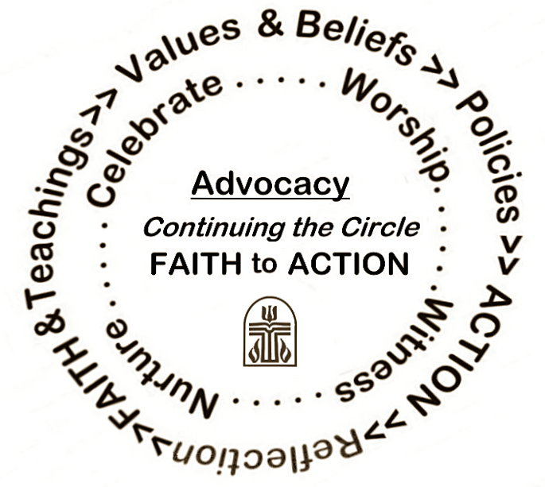
Homelessness and Affordable Housing Sunday 2012
This Sunday, August 5, 2012, the Presbyterian Church (U.S.A.) turns its prayers, and hopefully its hands, toward homelessness and the dire need for affordable housing. Tonight, 750,000 to 1 million souls will sleep on the streets, many of them veterans, families with children, and youth and young adults.
As Christians, we are called into a covenantal community that welcomes and cares for all members, especially those most vulnerable. In this community, worship and justice cannot be separated:
Is not this the fast that I choose: to loose the bonds of injustice, to undo the thongs of the yoke, to let the oppressed go free, and to break every yoke? Is it not to share your bread with the hungry, and bring the homeless poor into your house? (Isa. 58:6−7)
So on this Sunday, let us offer God the fast God chooses.
Find out more at http://justiceunbound.org/action-alerts/homelessness-affordable-housing-sunday/
Get involved with the Presbyterian Network to End Homelessness: www.pnteh.org
Donate to the One Great Hour of Sharing (4% supports congregation-based community organizing focused on providing affordable housing): http://www.presbyterianmission.org/ministries/specialofferings/one-great-hour-sharing-offering/

